**Report** MTN.BI.08 Materialized Views

by Aliaksandr Labayeu

**REFRESH**

**ON COMMIT**

* fast refresh is to occur whenever the database commits a transaction that operates on a master table of the materialized view.

**ON DEMAND**

* database will not refresh the materialized view unless the user manually launches a refresh through one of the three DBMS_MVIEW refresh procedures.

# ON DEMAND

CREATING MV with “ON DEMAND ”

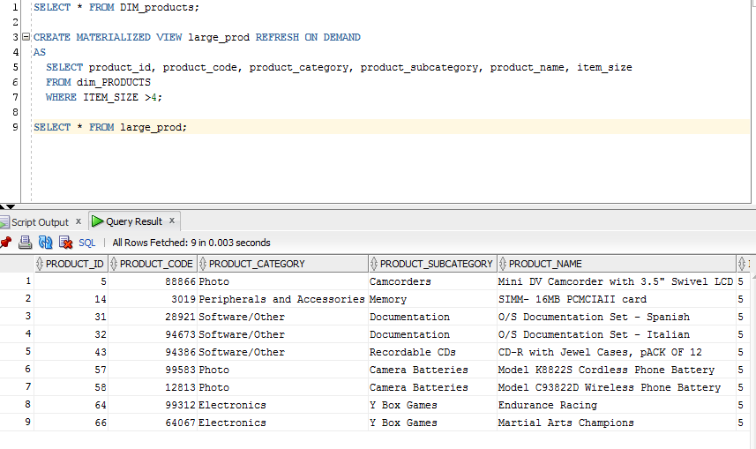

Table UPDATE causes changes in the table

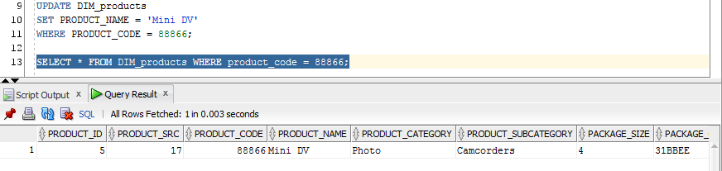

Materialized view has no changes:

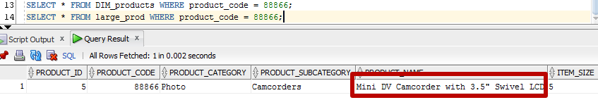

“on demand” refresh

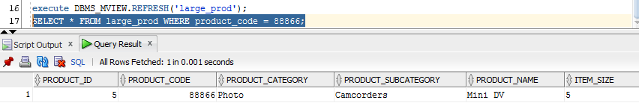

# On commit

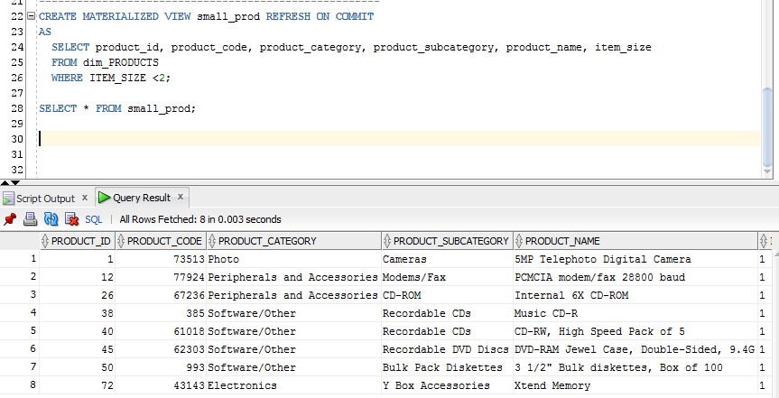

Providing some changes:

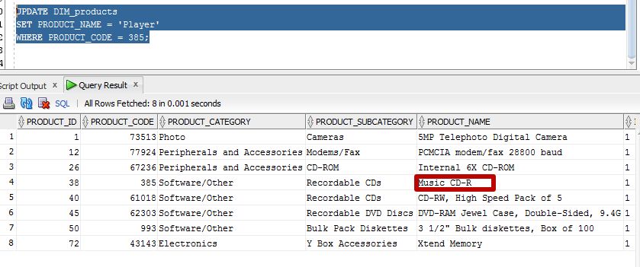

Changes in MV after COMMIT:

